# **Docker – Assignment**

Assignment – 1

1. Install the yum

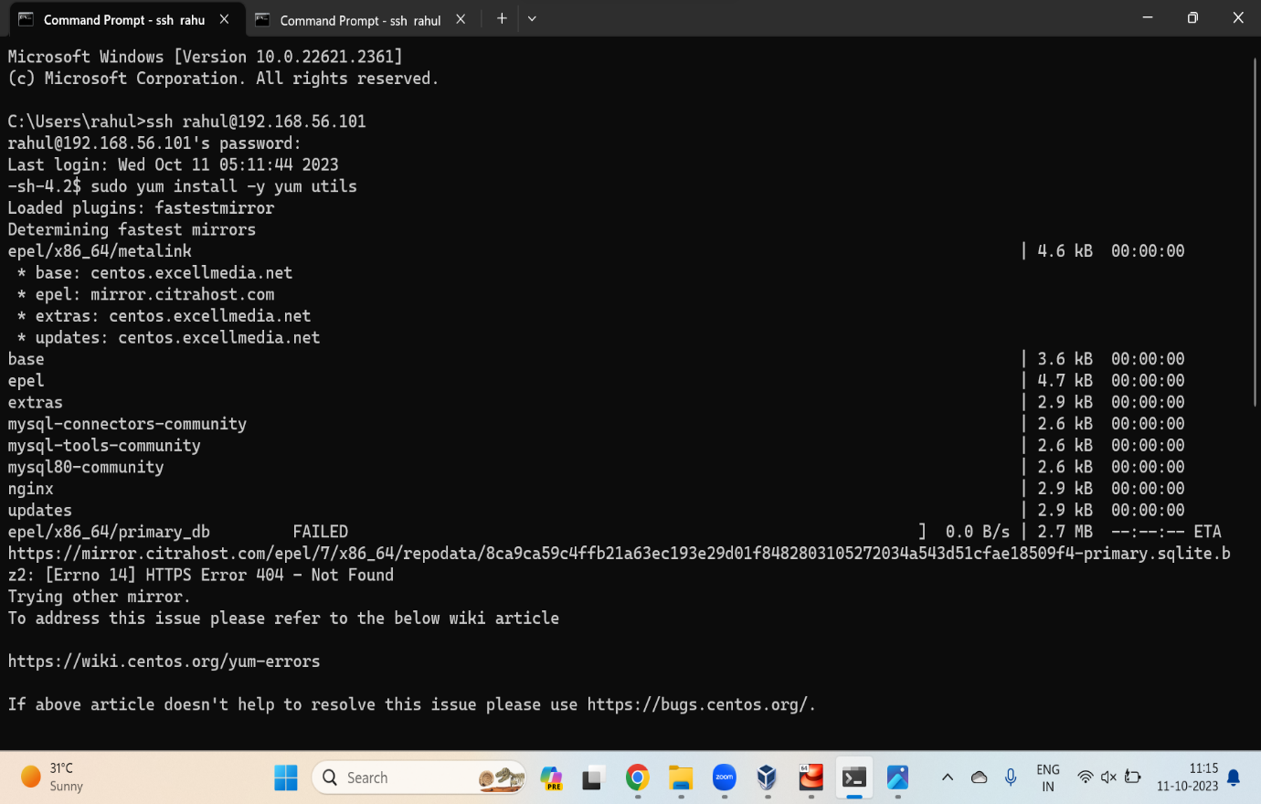

1. Install Docker

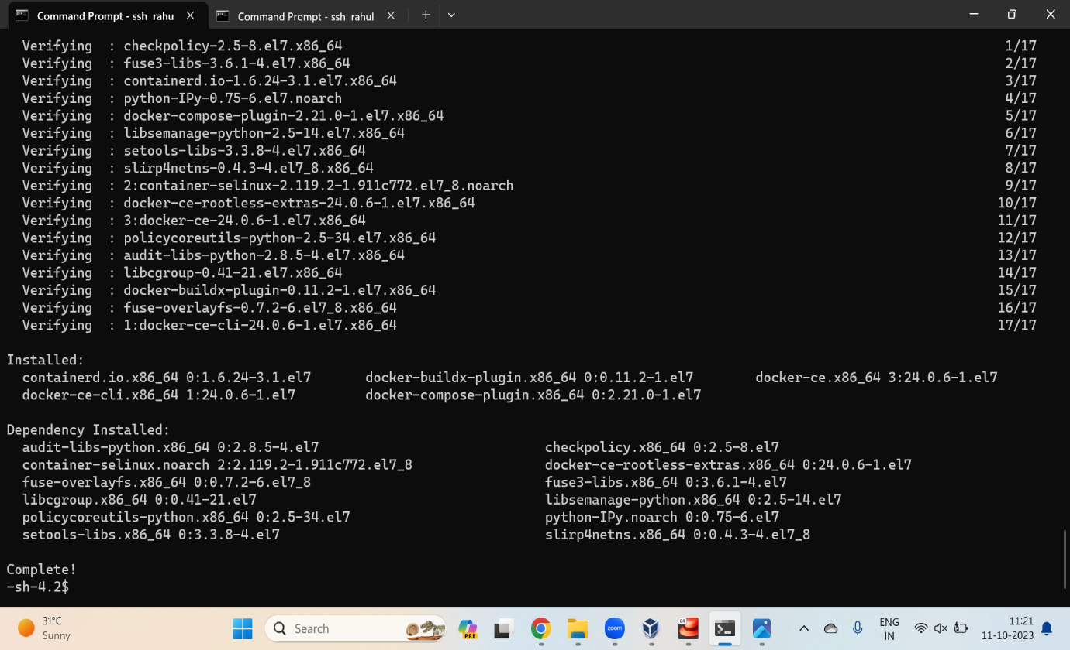

1. Start Docker

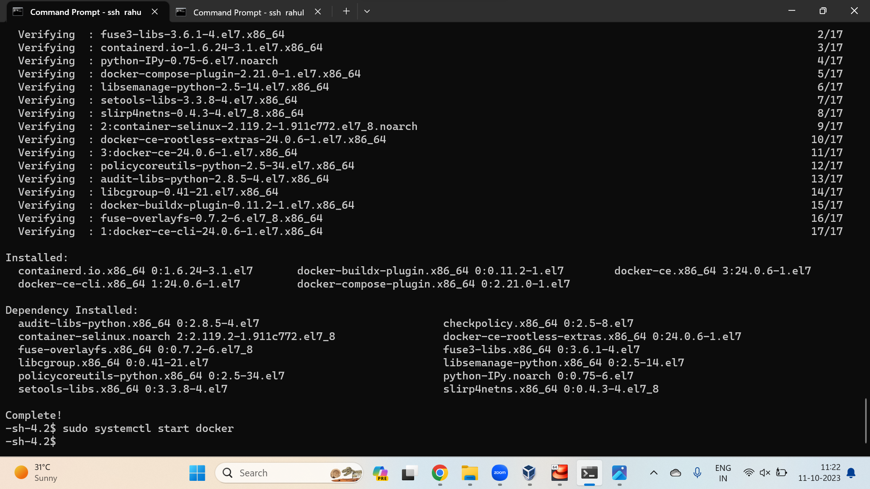

1. Verify that Docker Engine installed correctly by running the hello world image

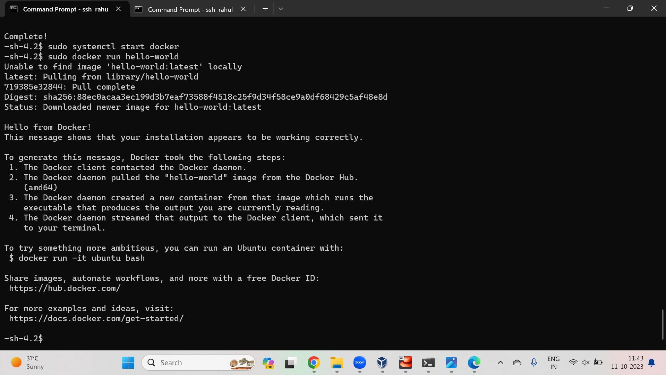

1. Create a Docker file using vi Dockerfile

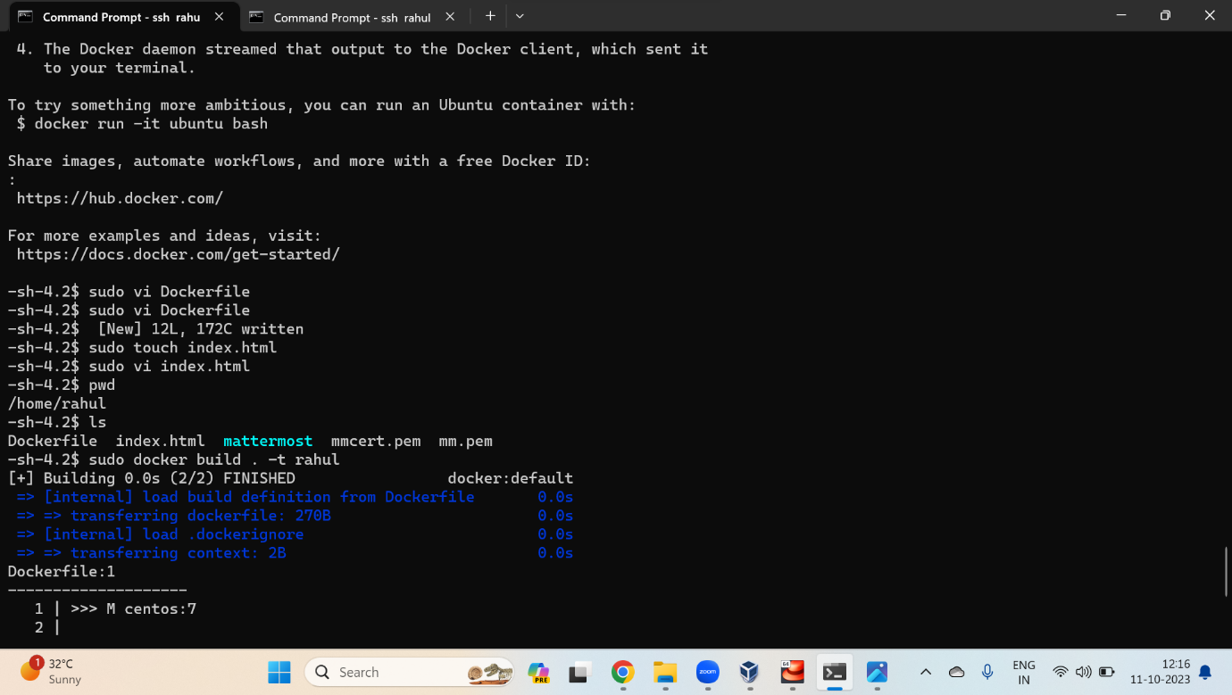

1. Create a file index.html
2. Build the image

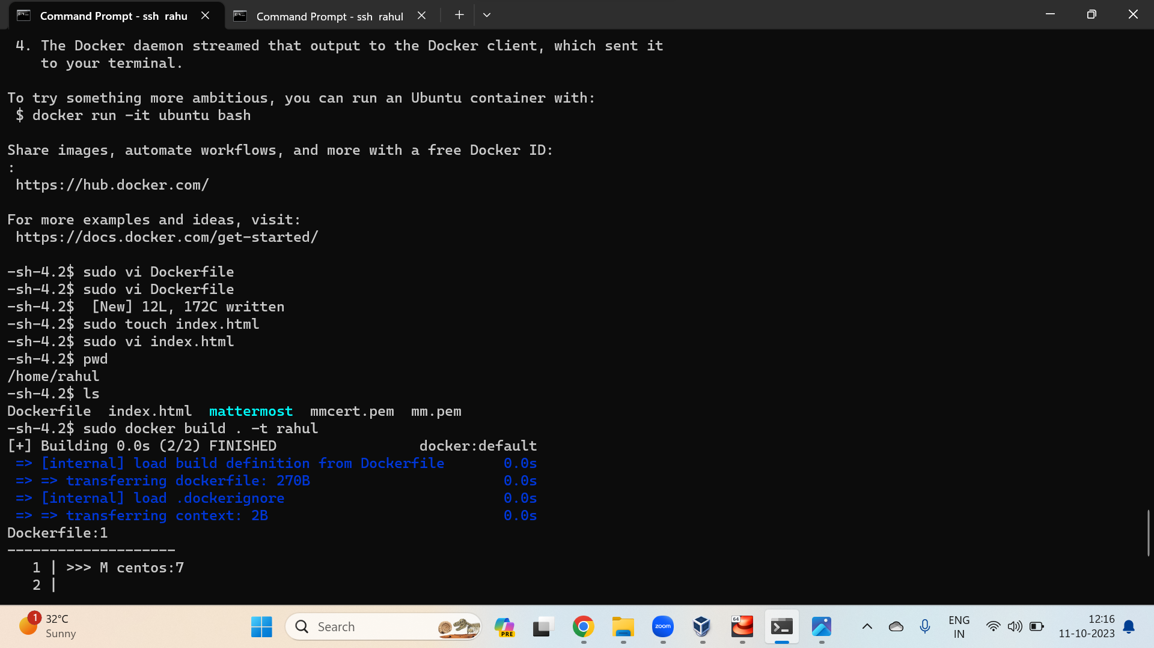

1. Verify the docker image
2. Run the docker image
3. Start the container

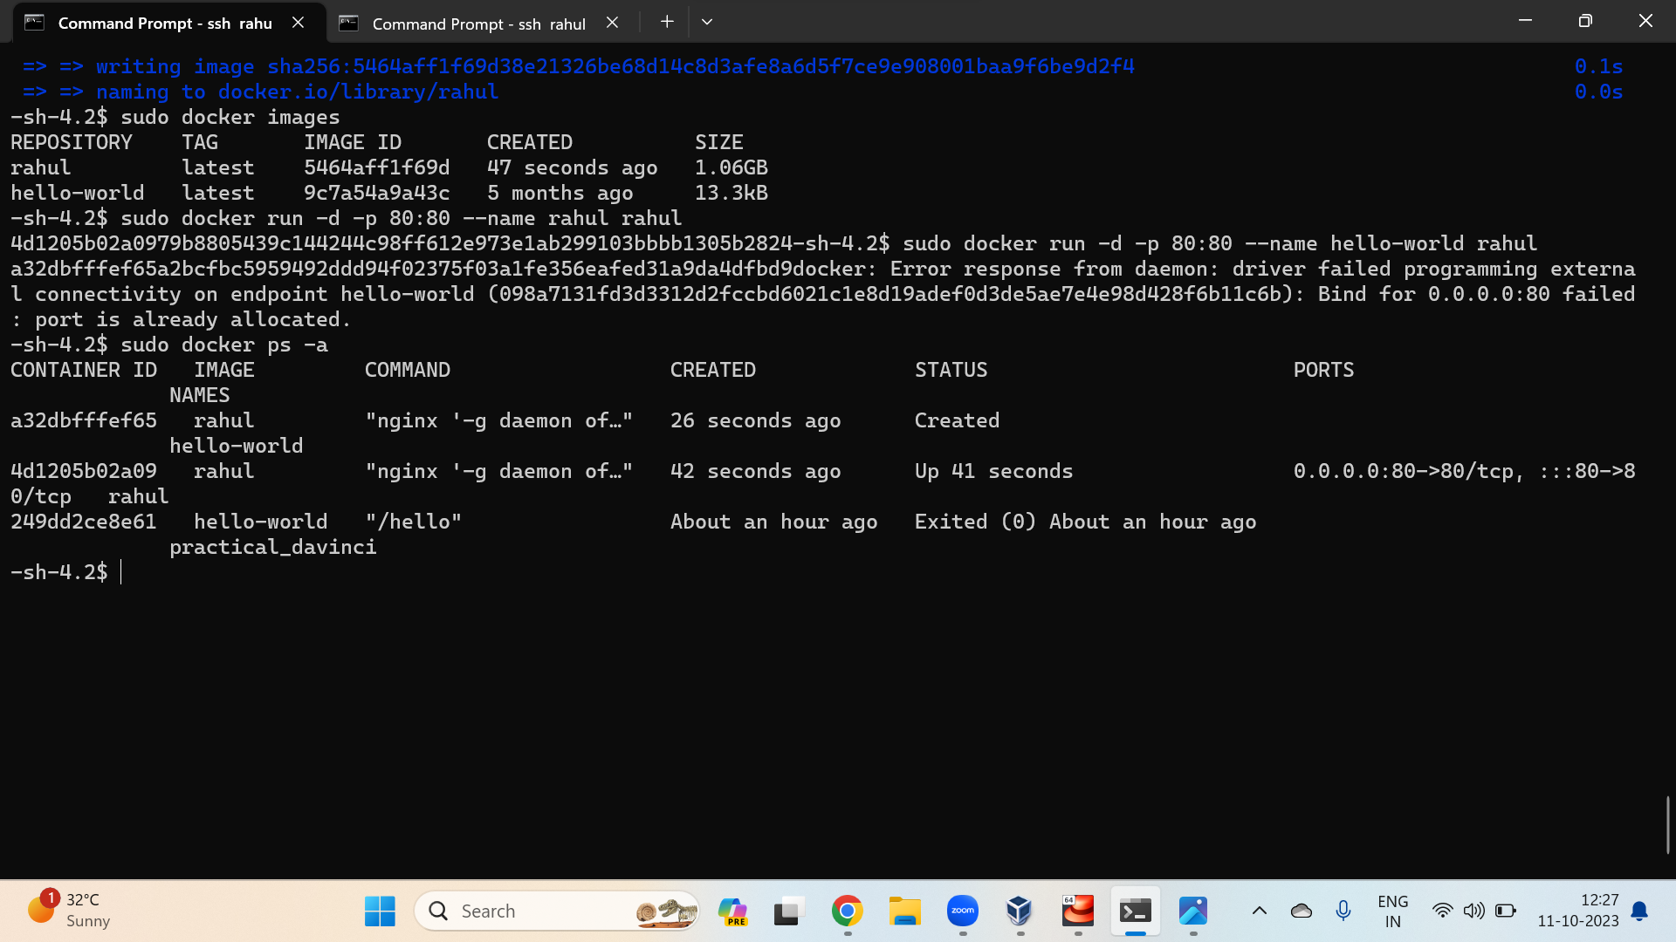

1. Run curl

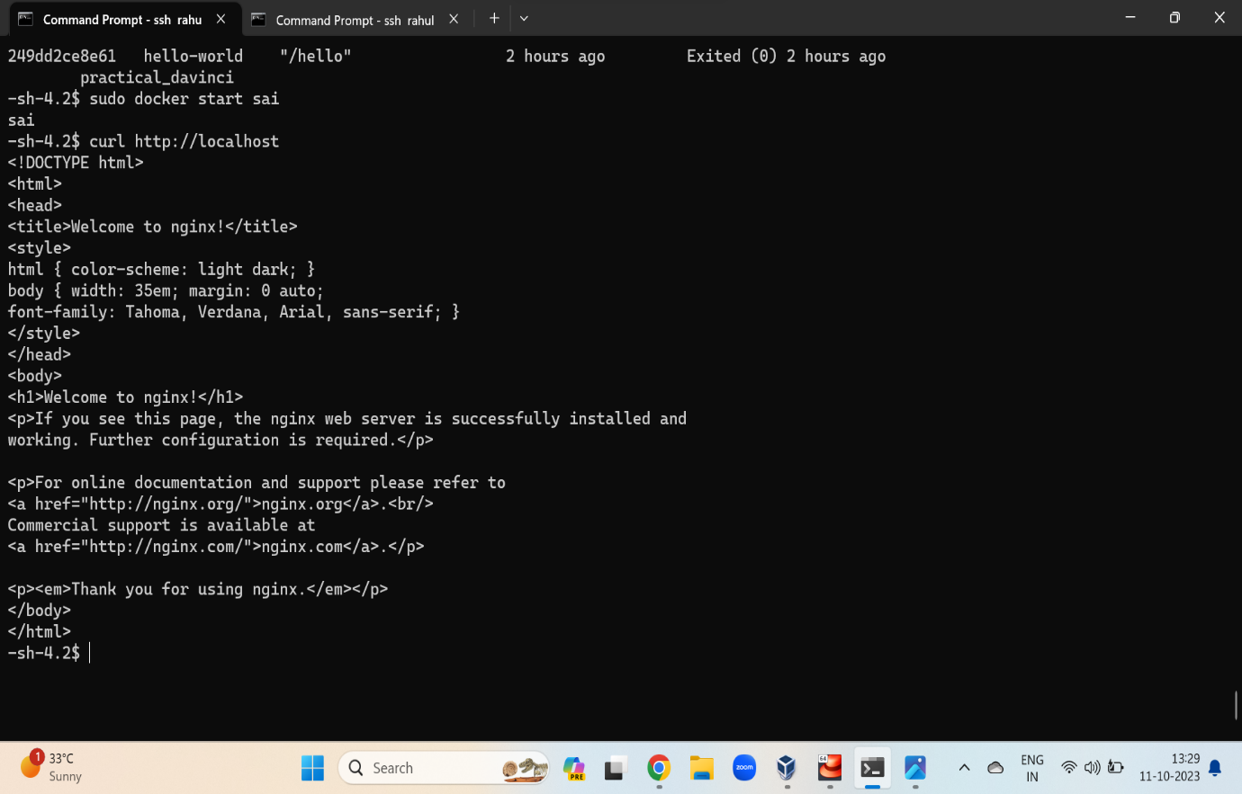

Assignment – 2

1. Create a dockerfile to build a mattermost image
2. Create config.json file

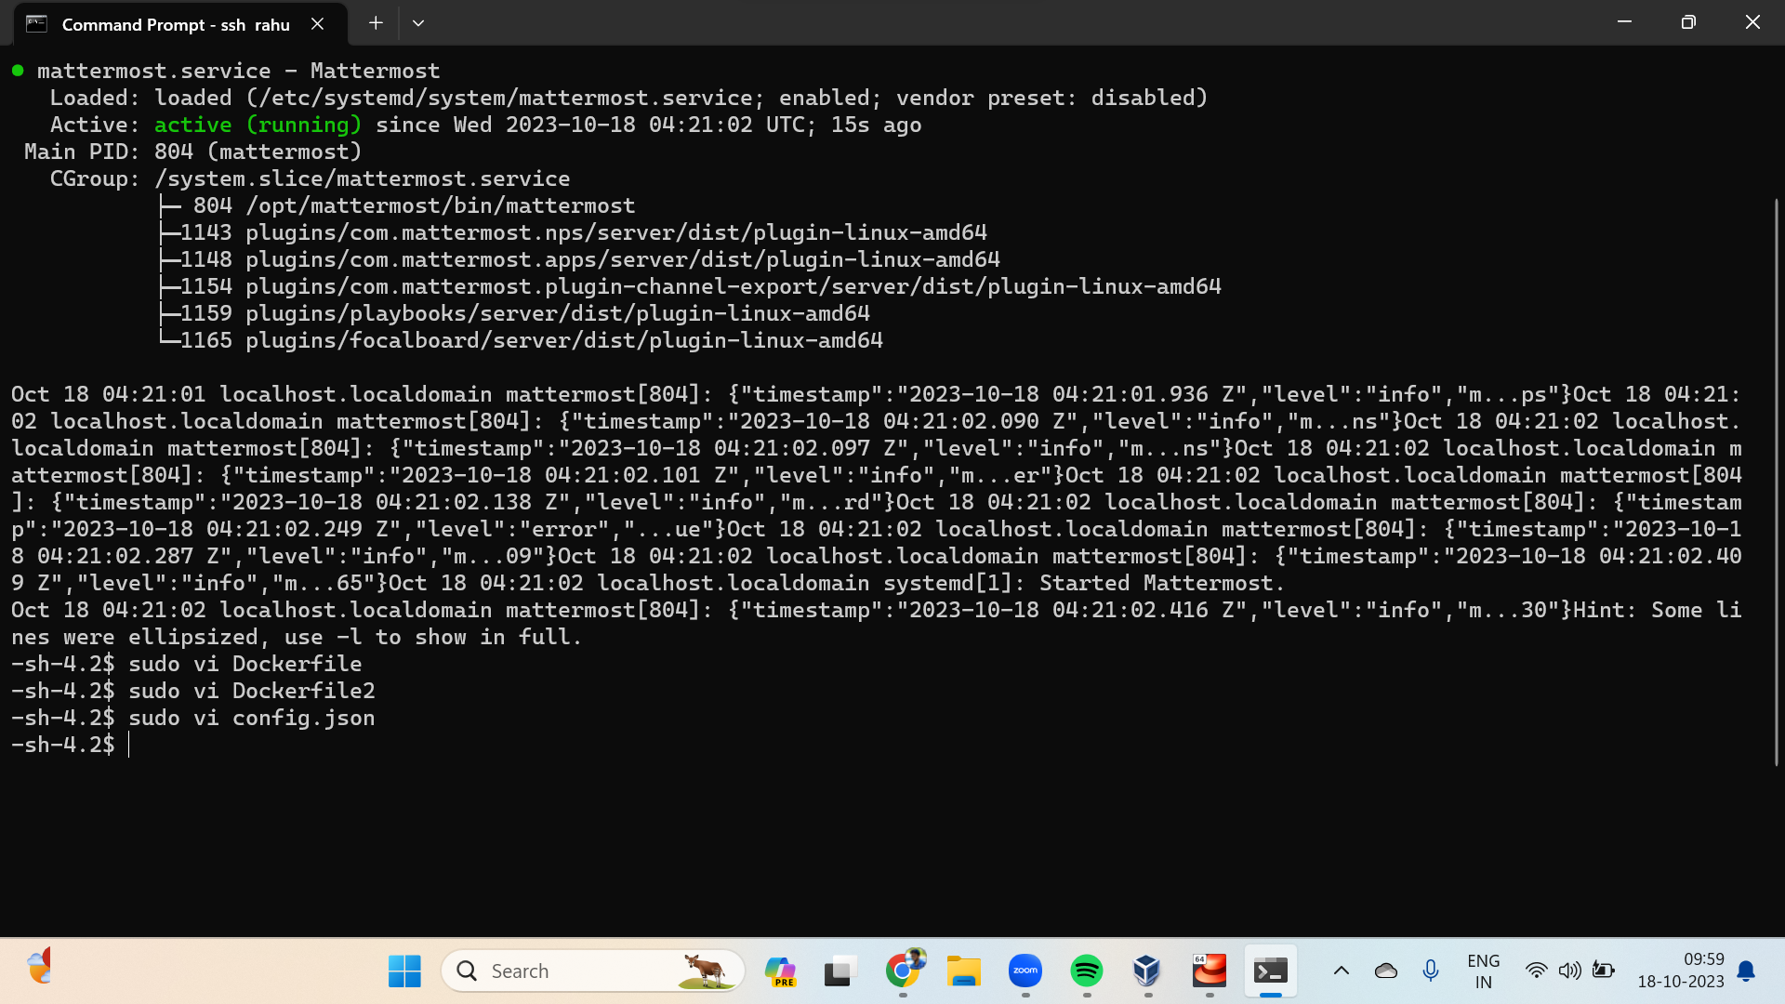

1. Change the sql server ip

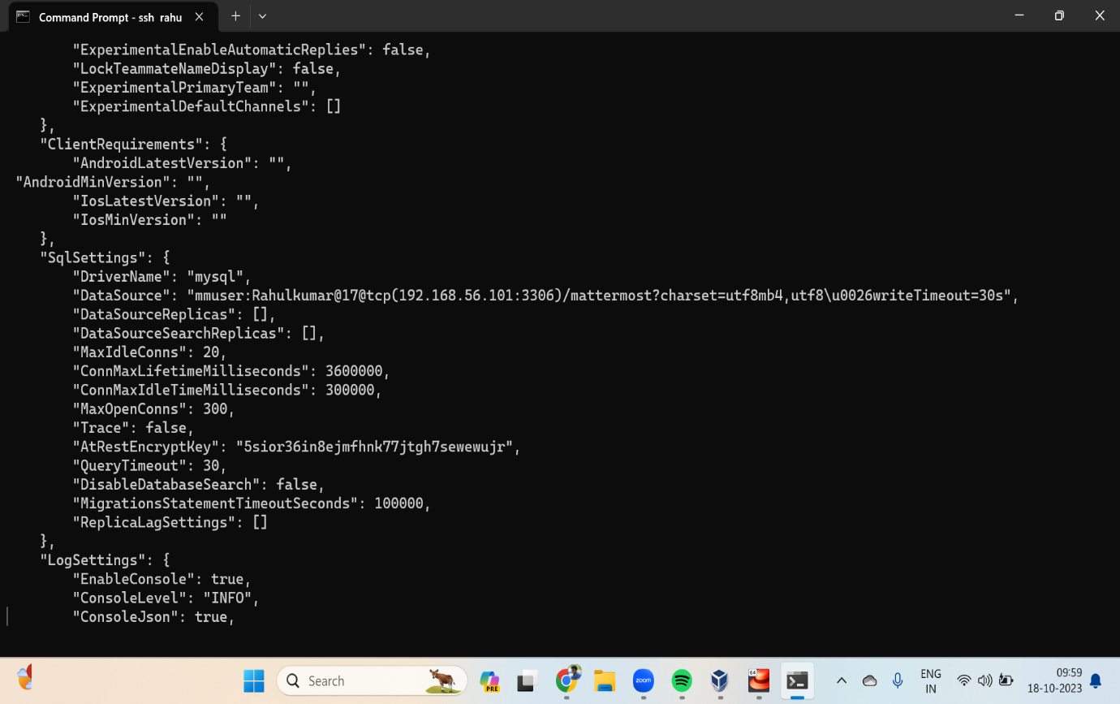

1. Build the image using following command
2. Run the docker image
3. Start the container

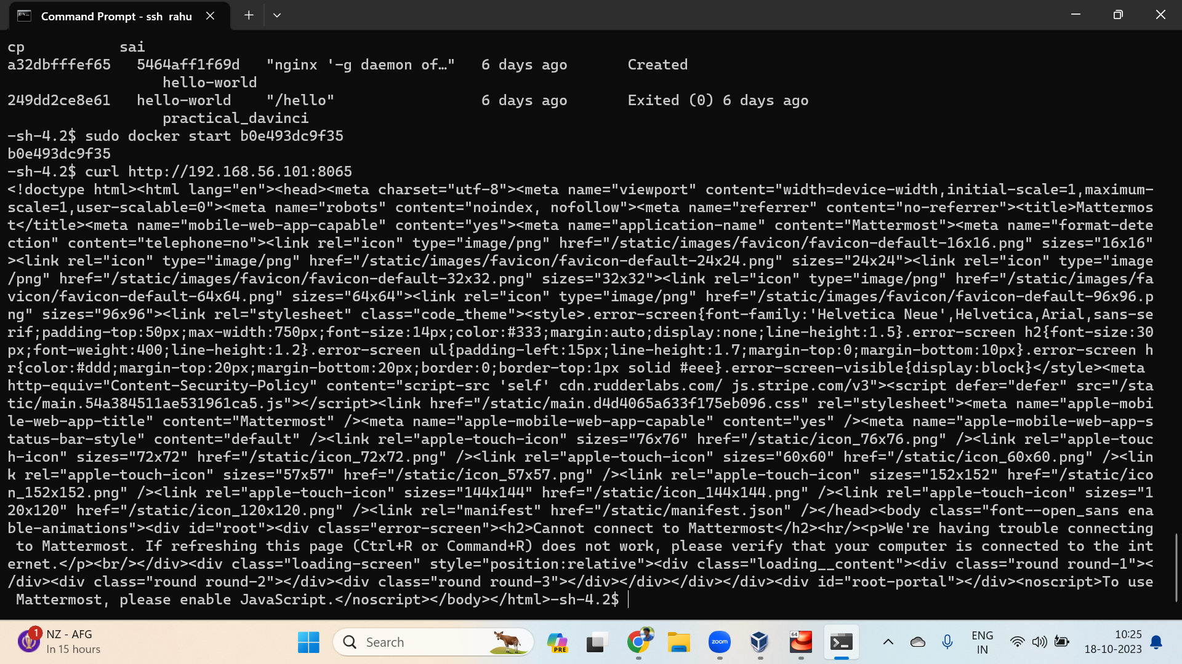

1. Verify the mattermost server

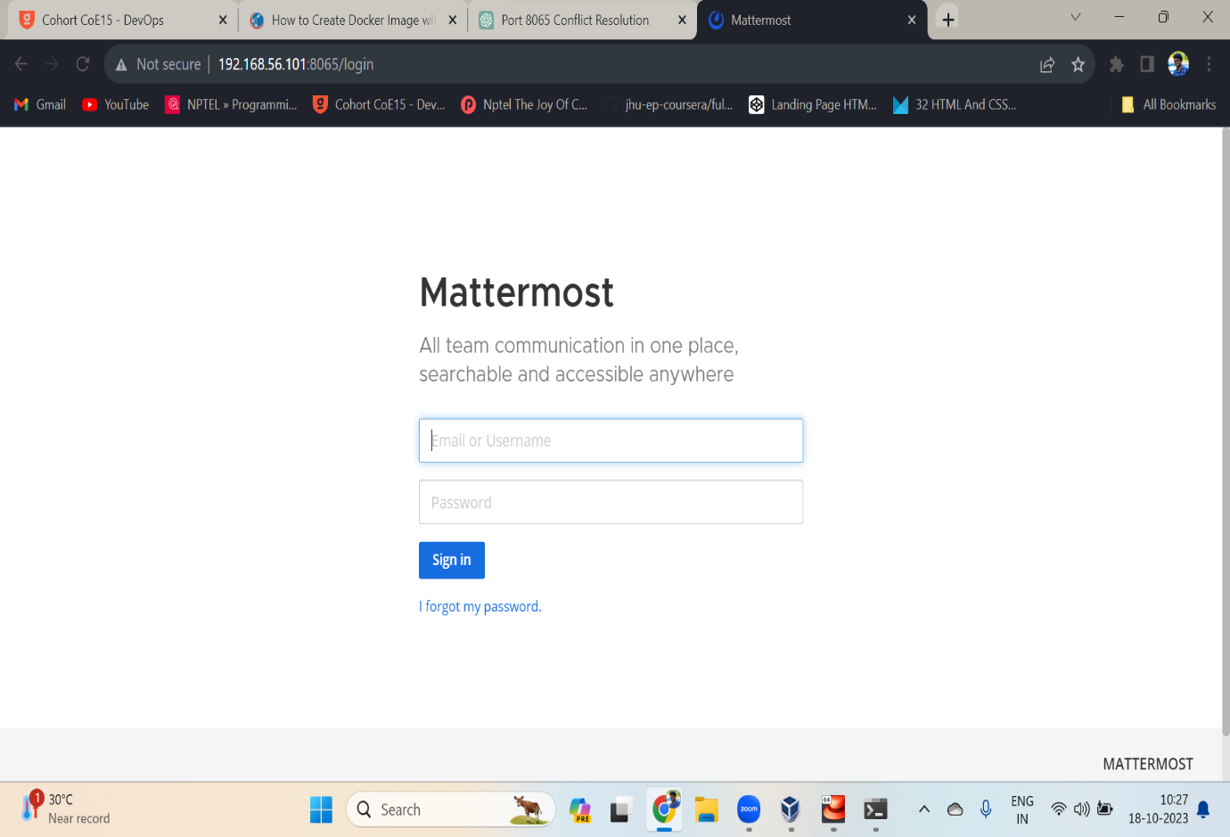

Assignment – 3

1. Create a dockerfile
2. Create a init.sql file
3. Perform build

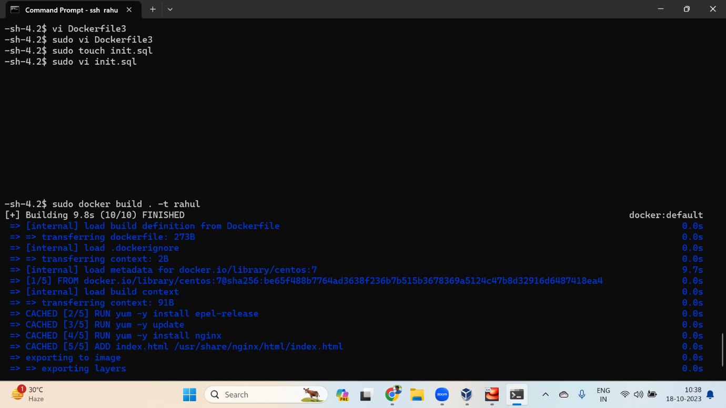

1. Run the image
2. Generate root password

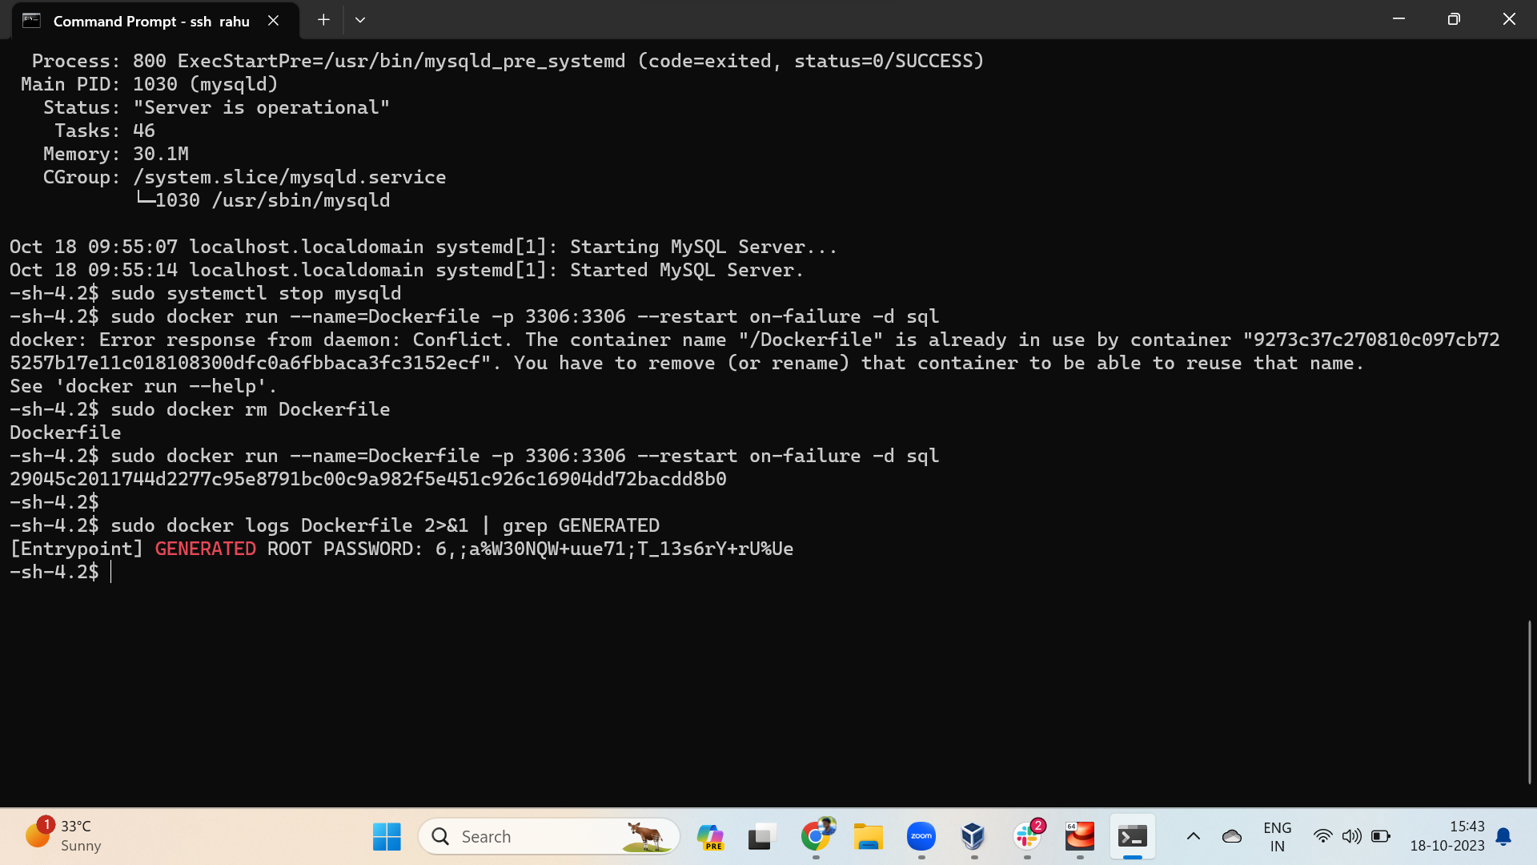

1. Perform docker exec
2. Change the root user password

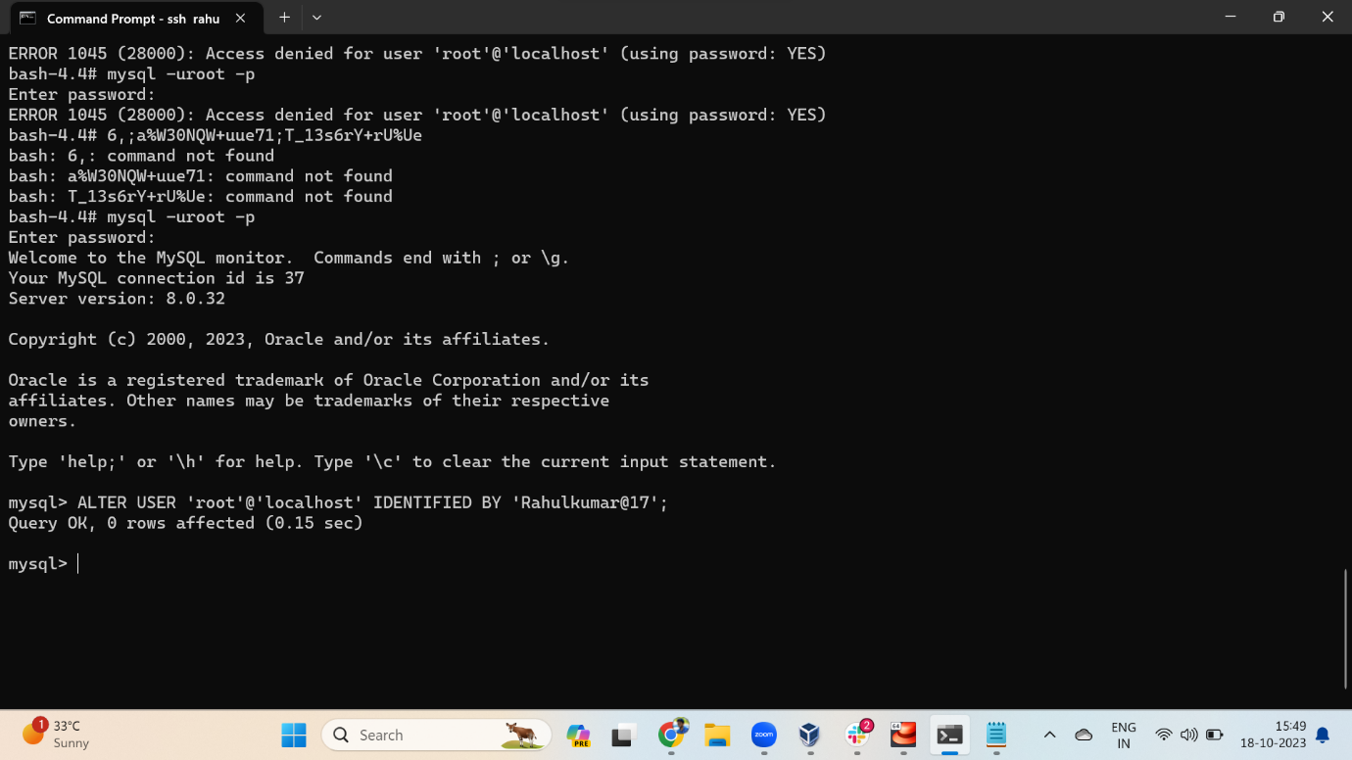

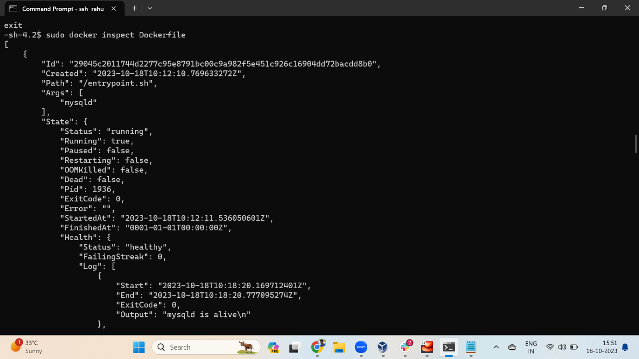

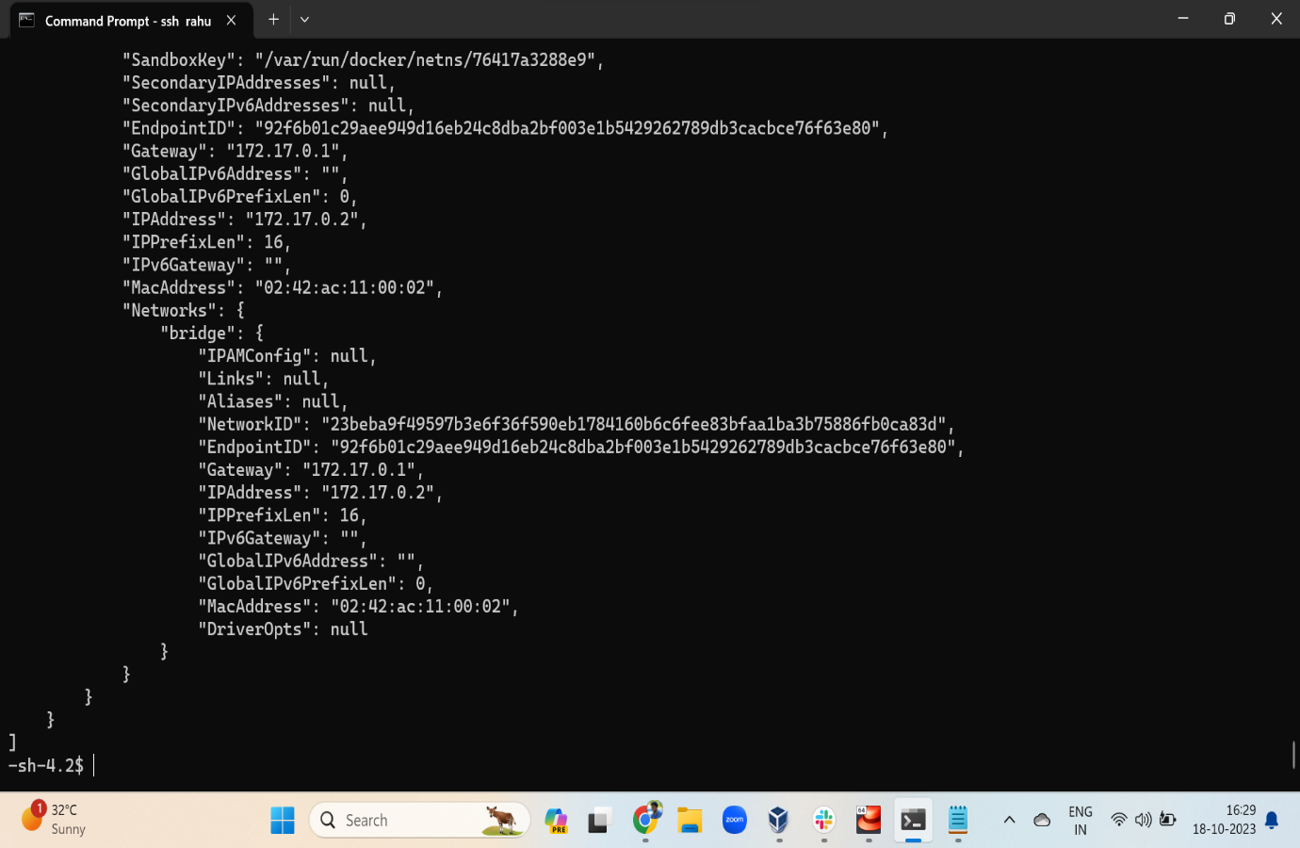

1. Restart mattermost

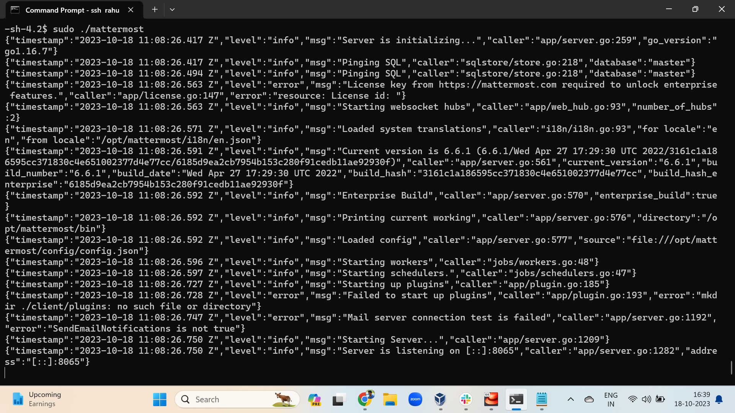

Assignment – 4

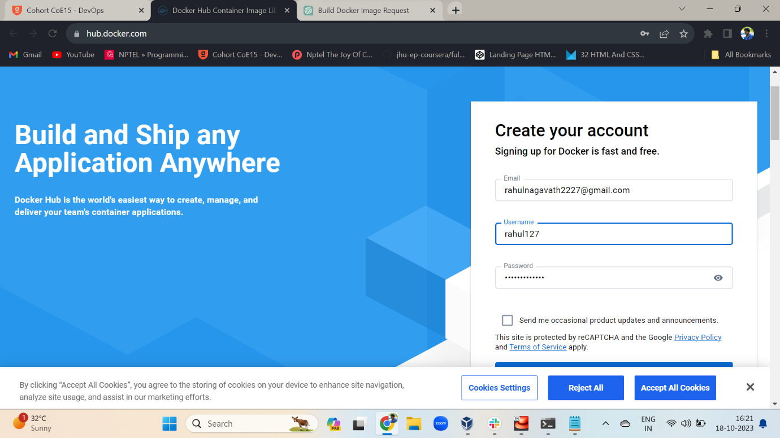

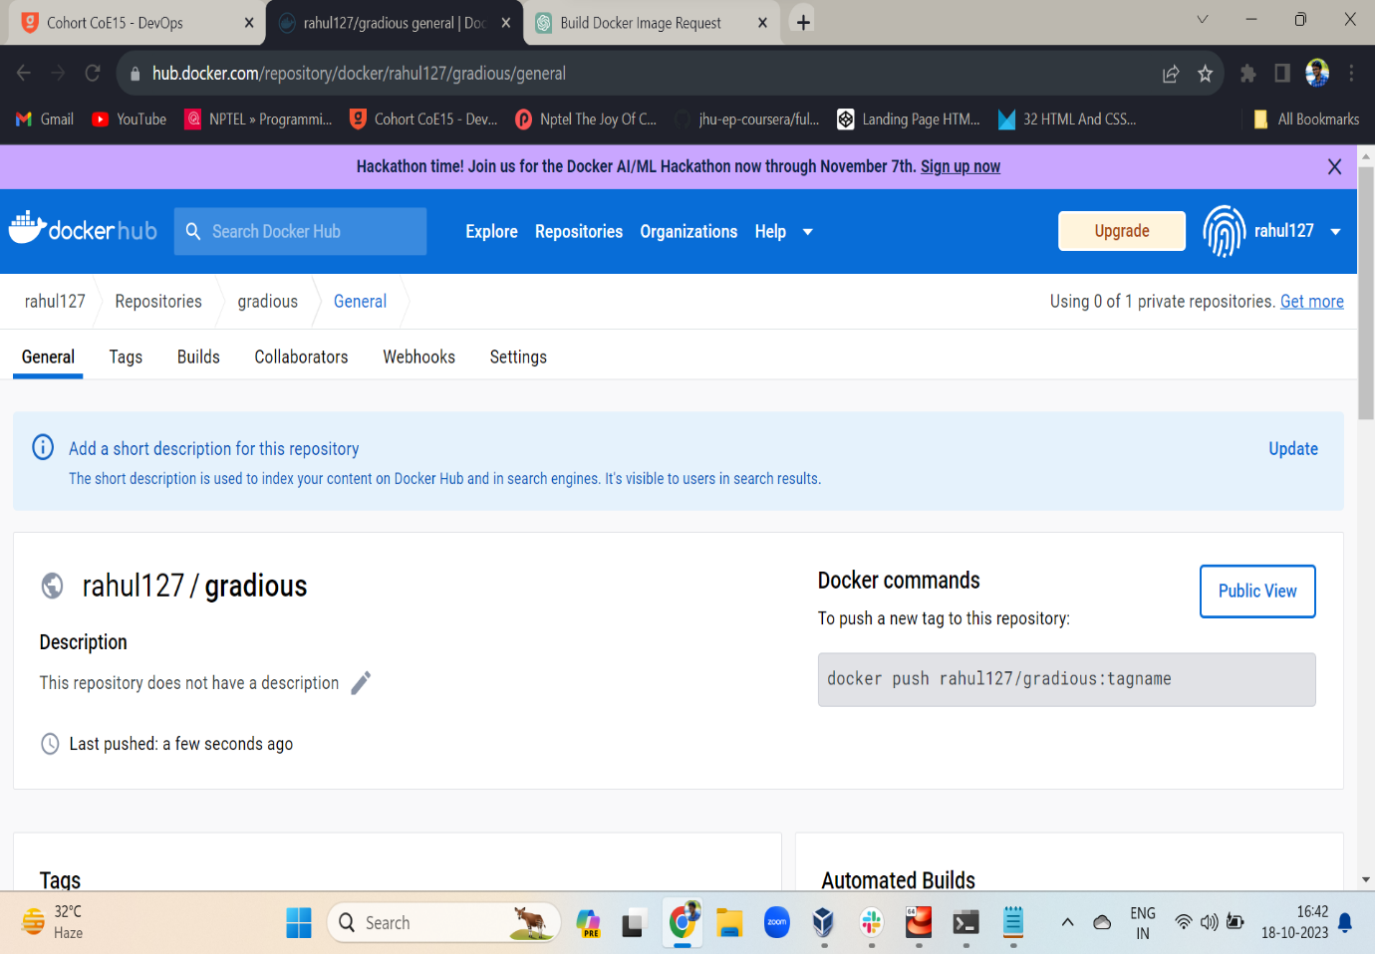

1. Sudo docker commit
2. Verify the image commit succeeded
3. Login to your docker

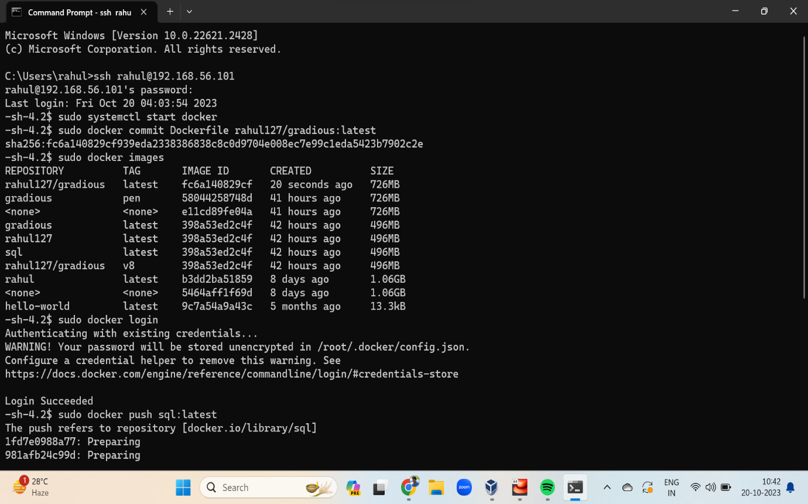

1. Sudo docker push

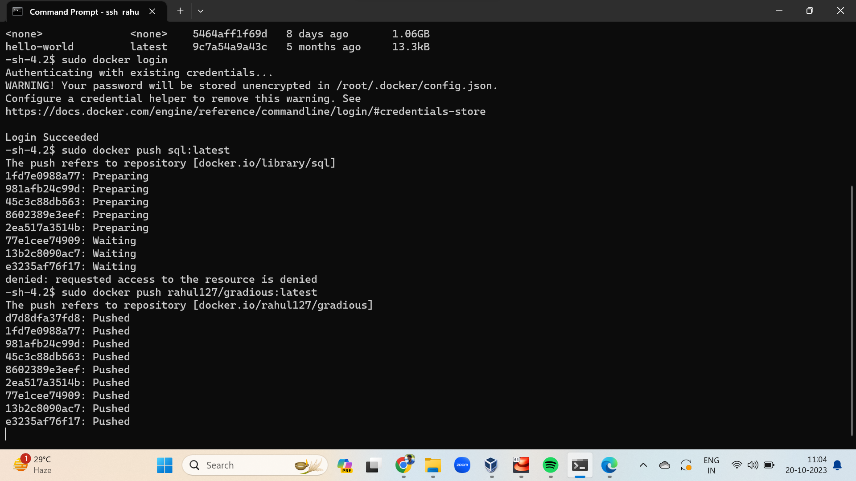

1. Once docker push is succeeded verify the docker hub repo

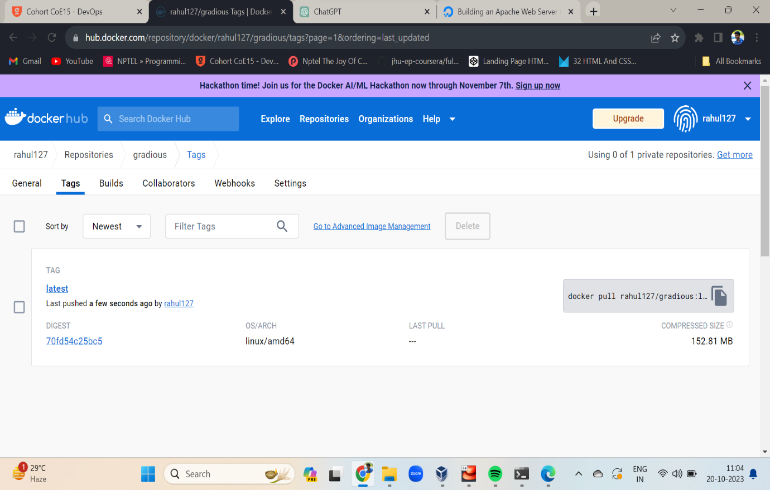

Assignment – 5

Write a docker file to host a simple html content using apache web server

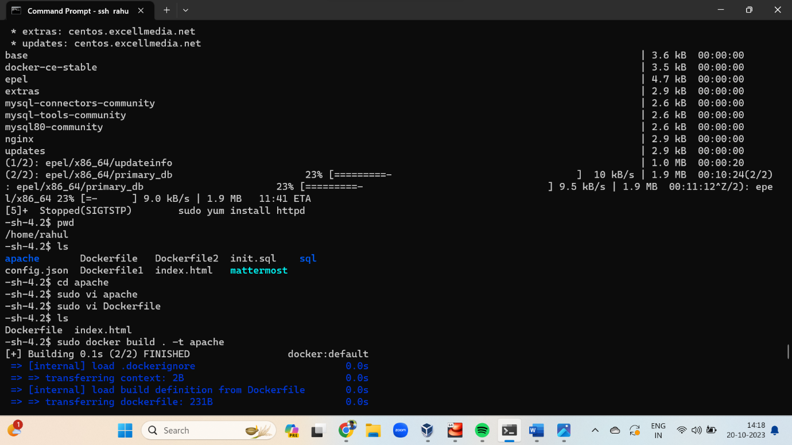

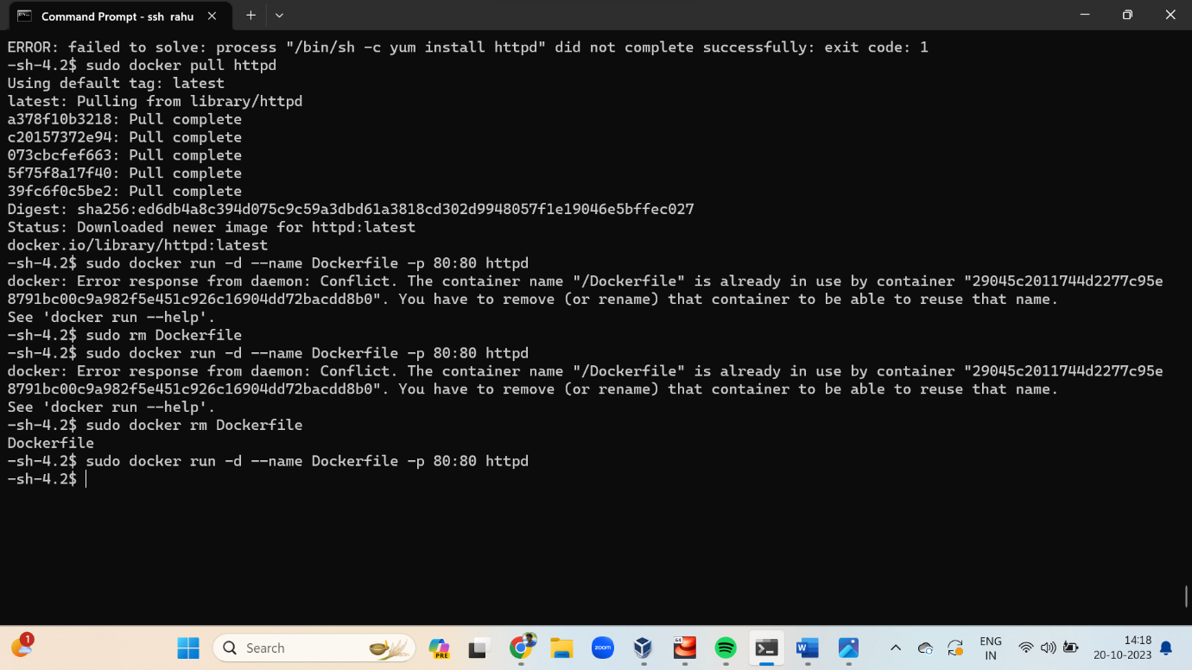

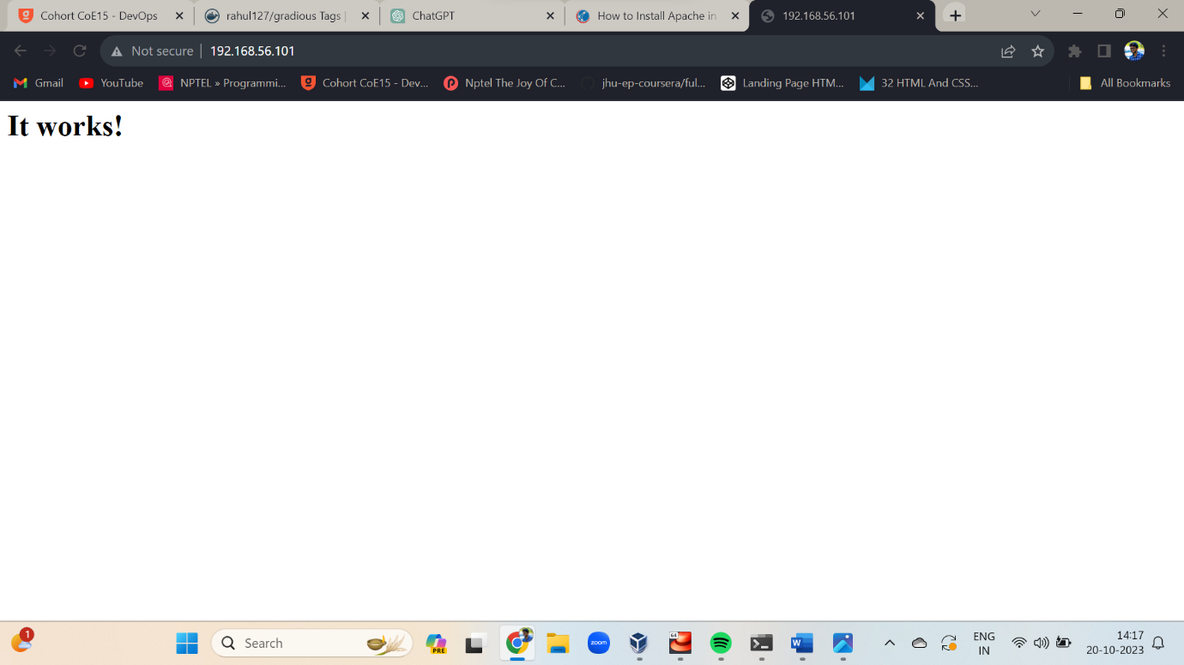

Assignment – 6

Mount a host directory as a docker volume

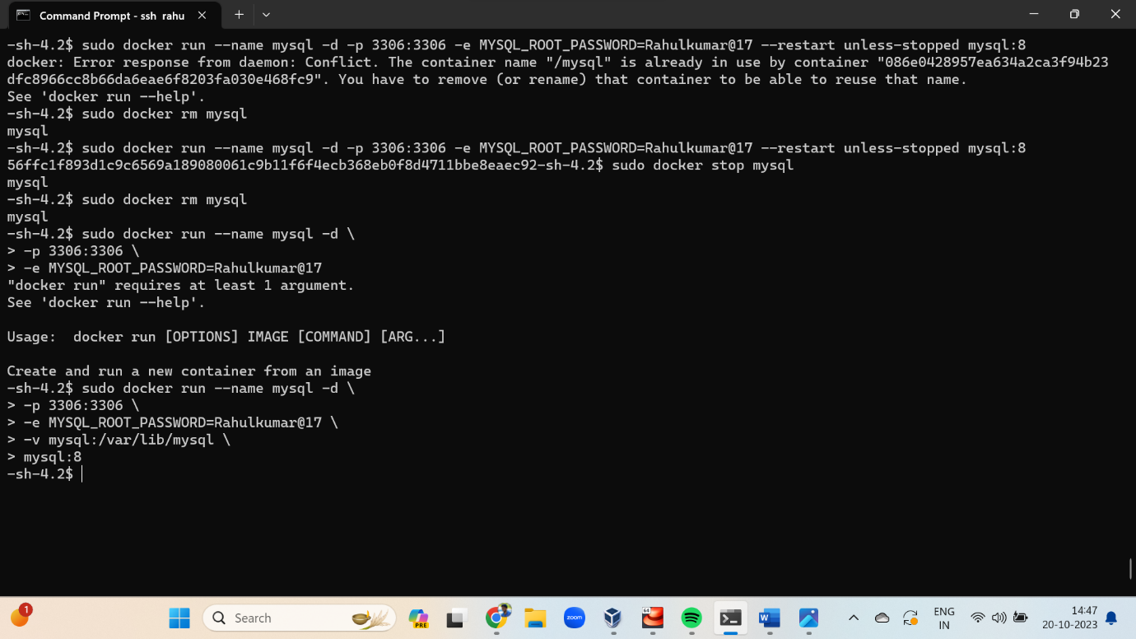

Assignment – 7

Create a file named docker-compse.yml

